Dice Game - Game Design
Intro:
I have broken down the process of the game in four main steps, and I will be numbering these main steps in my flowchart and stepwise refinement.
The first step is about the start of the game; it will start with the high scorer’s name and their high score as mentioned in the requirements.
The second step is as mentioned in the requirements, will be about welcoming the player to the game and will take their name as input.
The third step that I have broken the game down into is about the display of the instructions and the rules that are mentioned in the brief, as I deem them to be suitable to be displayed at this stage of the game, so the user knows how the game works.
Lastly my fourth step will be broken down into multiple steps.
4a) This step will involve having three six-sided dice and randomizing their number in each round (after taking an input from the player) of the game from a random number between 1-6 with a FOR loop?
4b) This step will be the last main step game, which will have its own main loop, and this main loop will be about checks. There shall be two sub-steps or two sub-functions here which will be focused about on checks. Check for rules and check for highscore and then lastly the last sub-step that will come after the highscore check will be about either initiating another round of the game or not.

Modular Design / Stepwise Refinement

1 – GAME START / Beginning

OUTPUT highScorerName + highScore

2 – INPUT playerName and welcomeMessage

…
4 – Mainloop
3 – OUTPUT _instructions and _rules
Test Number | Description of test | Test Data | Expected outcome | Actual Outcome
1 | `Uppercase subprogram check | Valid = AAAAAAA  Invalid = aaaaaaa  Type = 123432134  Extreme = -1123 | Asked to re-enter password if invalid and not containing an Uppercase character. | All data produced same output of an empty return. No reinputting of the password.  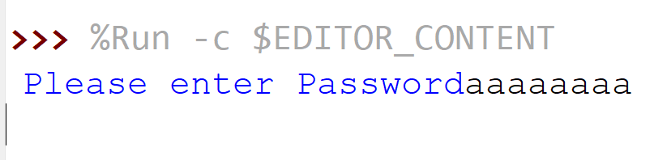
2 | Logic test after moving the input inside the main loop  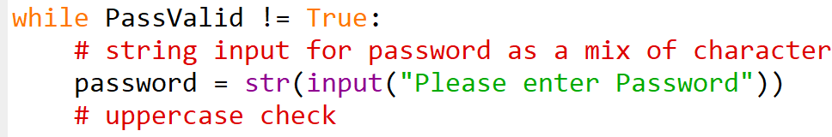 | Valid = AAAAAAA  Invalid = aaaaaaa  Type = 123432134  Extreme = -1123 | Asked to re-enter password if invalid and not containing an Uppercase character. | 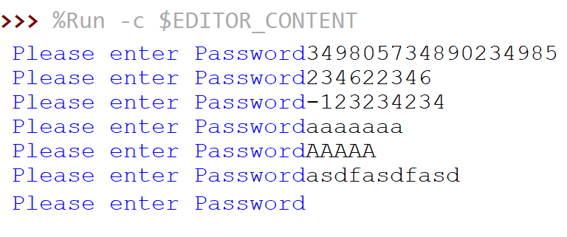
3 | Testing output for the uppercase subprogram to ensure it checks if the characters are valid. Only checking uppercase for now.  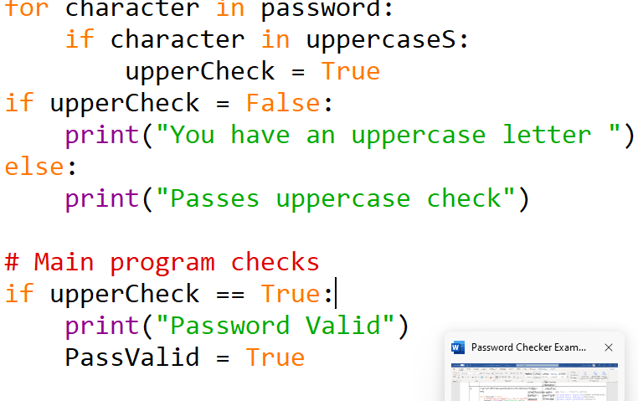 | Valid = AAAAAAA  Invalid = aaaaaaa  Type = 123432134  Extreme = -1123 | Output of passes uppercase check .  Output of Valid password | Ouput needs work for user when incorrect. Displays the wrong message.  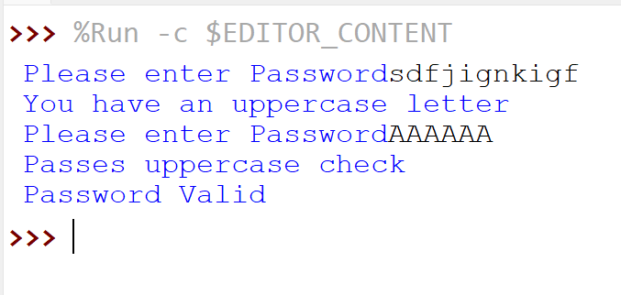
1 | 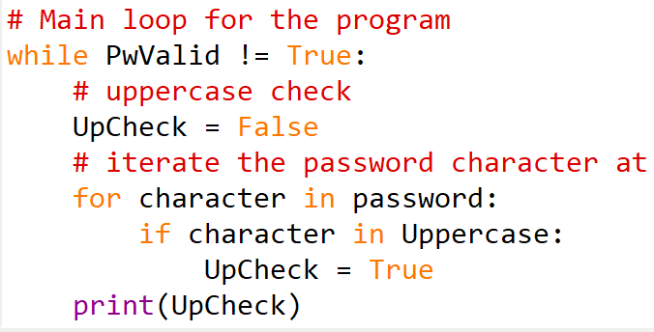  Check inputs for uppercase characters sub program . | Valid = AAAAAA  Invalid = aaaaaaa  Erroneous = 2563465234 | True for Valid  False for Invalid  Return to Input | 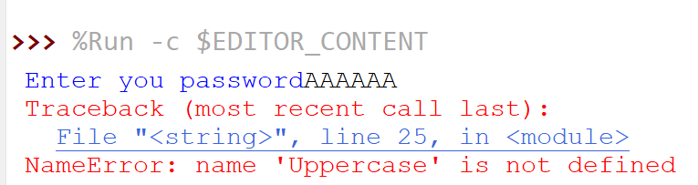  Check variable names  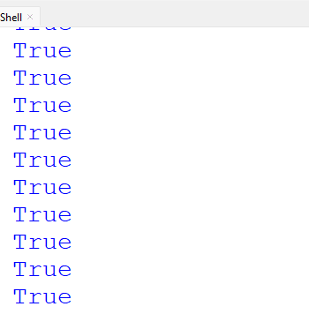  Creates infinite loop
1.1 | 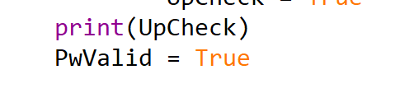  Break the loop after the check to show whether the vaild for uppercase has worked. | Valid = AAAAAA  Invalid = aaaaaaa  Erroneous = 2563465234 | True for Valid  False for Invalid  Return to Input | 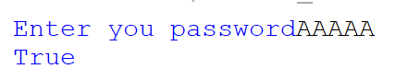  Works with Valid data
 | Checking sub program for uppercase letters  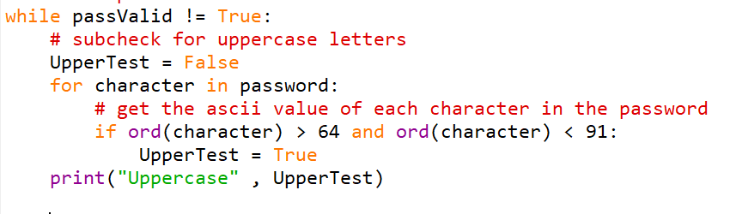 | Valid = AAAA  Invalid = aasdasd  Bound = sdiaisdbf (long string)  Erroneous =  -12  Blank = ‘’ | Uppercase output should be true for valid data.  False for non. Re enter the password. | Creates infinite loop as input is outside of the main loop  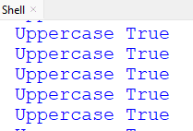
1.1 | Move input inside the main loop and then test the inputs.  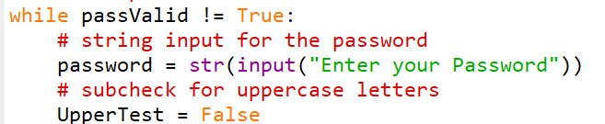 | Valid = AAAA  Invalid = aasdasd  Bound = sdiaisdbf (long string)  Erroneous =  -12  Blank = ‘’ | Uppercase output should be true for valid data.  False for non. Re enter the password. | 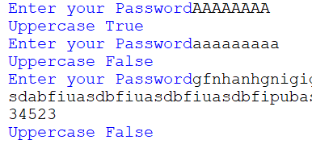  Passes test to check if Uppercase or not with Boolean true or false.

